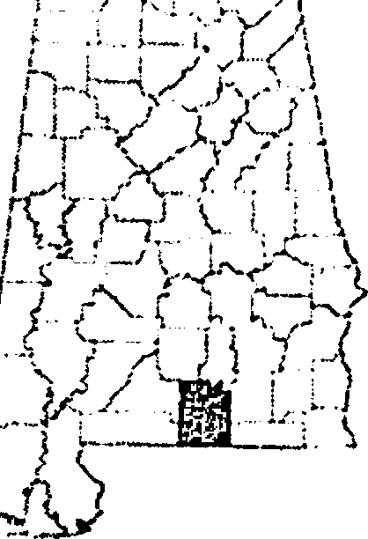
COVINGTON COUNTY REVENUE COMMISSION
George L Patterson, Jr
1 N. Court Square Andalusia, AL 36420
T: 334-428-2540 F: 334-428-2575

EXEMPTIONS ON PROPERTY TAX AVAIIABLE

All exemptions must be APPLIED for by the Owner/Deed Holder

  - Homestead Exemption (Primary Residence)
    - Normal Homestead
    - Over 65 Years Old (Age & Income)
    - 100% Disability through SSA/VA/Physician Affidavits
  - Personal Use/Summer Home - Not for rent/sale lease
  - Current Use - Agricultural or Timber land
  - Grain Bins In Use Exemption
For information on how to qualify for and apply for these exemptions, please contact the Covington County Revenue Commissioner's Office. Applications are available and accepted year-round. Alabama's lien date is October 1 each year, and all applications are due by December 31. The application may apply to the NEXT tax year, depending on the time of filing. We will gladly inform you of what year to expect the exemption to be applied, as we do not operate in a regular calendar year.

Information and Updates are available from our office in the following locations:
- The Covington County Courthouse
- The Covington County Administrative Building
- In articles published in local newspapers throughout the year
- On local radio stations
- Our Covington County Revenue Commissioner's Office Facebook page
- The Covington County Website WWW.COVCOUNTY.COM

